Product Performance Dashboard

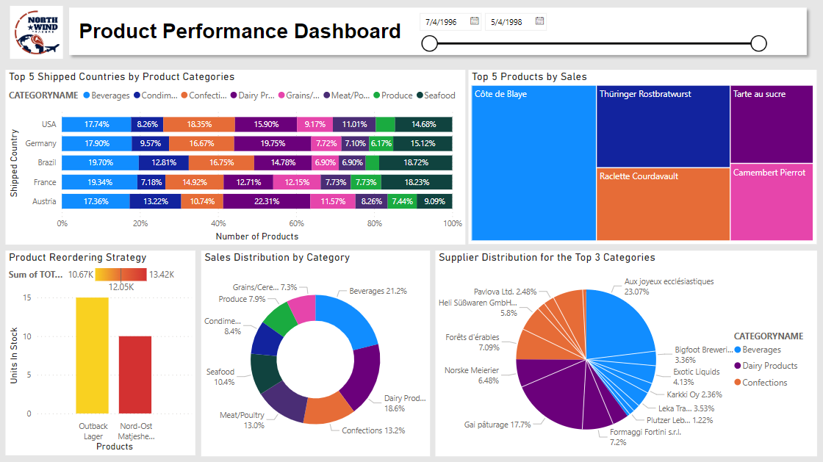

The Product Performance Dashboard serves as a critical tool for NWT, offering a comprehensive understanding of their product-related operations. It includes visuals that pinpoint the top-shipped countries, the distribution of discontinued products, the best-performing products by sales, a reordering strategy based on stock levels, and a breakdown of supplier contributions to the top product categories. This dashboard directly addresses user stories on the Trello board related to product management and more. By visually presenting essential data, it empowers NWT to make informed decisions about marketing strategies, inventory management, and supplier collaborations. The dashboard is a cornerstone in NWT's endeavor to enhance product performance and streamline their supply chain, ensuring a competitive edge in the market.

**Visual 1: Top 5 Shipped Countries by Product Categories**

The 100% stacked bar chart provides NWT with crucial insights into its product distribution across the top 5 shipped countries—USA, Germany, Brazil, France, and Austria. By showcasing the proportional representation of product categories in each country, the visual enables NWT to tailor marketing strategies and optimize inventory based on regional preferences. For instance, identifying a higher demand for beverages in Brazil allows NWT to strategically focus its marketing efforts and inventory planning in this category for that specific market. This visual empowers NWT to make informed decisions regarding product distribution, marketing, and inventory management, catering to the unique preferences of customers in different international markets.

**Visual 2: Top 5 Products by Sales**

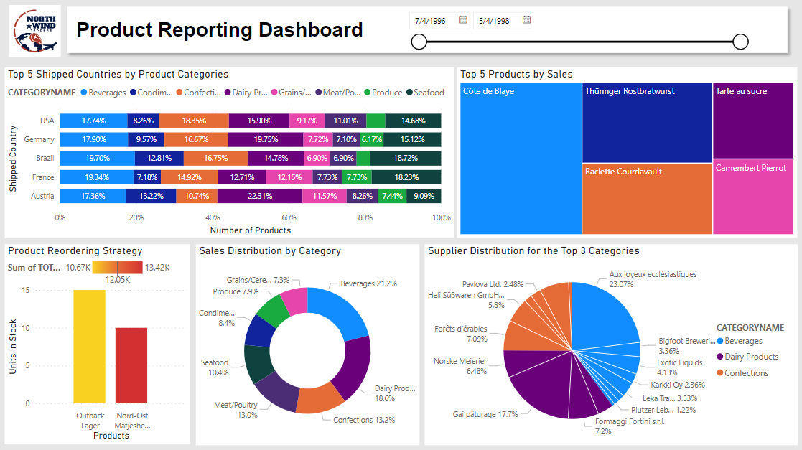

The treemap showcasing the top 5 products by sales provides NWT with a clear and visually intuitive overview of its best-performing products. By focusing on the highest-selling items, NWT can discern key trends and customer preferences. This visual aids in inventory management, ensuring that popular products are well-stocked to meet demand. Additionally, it guides marketing efforts by highlighting which products resonate most with customers. Understanding the top-performing products allows NWT to refine its product strategy, emphasizing successful items and potentially expanding related product lines. This insight contributes to informed decision-making and enhances NWT's ability to align its product offerings with customer preferences, ultimately driving sales and customer satisfaction.

**Visual 3: Product Reordering Strategy**



The column graph illustrating the product reordering strategy effectively identifies products that are low in stock by considering the combined units in stock and units on order against the reorder level. The color gradient, ranging from yellow to red, emphasizes the urgency of restocking, with red indicating higher demand. This visual enables NWT to pinpoint products requiring immediate attention and restocking efforts. The prioritized restocking strategy ensures that popular products are readily available, optimizing inventory management and customer satisfaction. This visual not only aids in efficient restocking decisions but also contributes to overall supply chain management, aligning NWT's product availability with customer demand dynamics.

**Visual 4: Sales Distribution by Category**



The donut chart representing sales distribution by category provides a concise overview of the product categories contributing to NWT's revenue. Notably, beverages, dairy products, and confections emerge as the top three categories, collectively constituting over 50% of the total sales distribution. Understanding the relative success of each category allows NWT to tailor its promotional efforts, allocate resources effectively, and identify potential areas for product expansion or refinement. By focusing on high-performing categories, NWT can optimize its product portfolio, ensuring alignment with customer preferences and market demands. The visual serves as a key reference point for product-related decision-making, contributing to NWT's overall business strategy.

**Visual 5: Supplier Distribution for the Top 3 Categories**



The pie chart delving into Supplier Distribution for the Top 3 Categories offers a targeted exploration of NWT's key product categories – beverages, dairy products, and confections – identified as top performers in terms of sales. Within each category slice, the chart meticulously breaks down the contribution of different supplier companies, providing a granular understanding of supplier engagement. By discerning which supplier companies play an important role in each high-performing category, NWT gains strategic insights for reinforcing its supply chain. This visual empowers NWT to cultivate stronger partnerships with suppliers that significantly influence the success of top-selling categories, ensuring a reliable and efficient supply chain. By concentrating efforts on these critical suppliers, NWT can proactively manage inventory, optimize collaboration, and fortify relationships crucial to sustaining the success of its top-performing product categories.

Reflection

*Experience Working on the Project*

My experience working on this project within the Agile framework has been both challenging and rewarding. The Agile methodology, specifically the Scrum framework, has provided a structured approach to project management that encourages collaboration and adaptability. One of the notable benefits was the emphasis on teamwork and the five core values of commitment, courage, focus, openness, and respect. While these values were challenging to embody consistently, particularly in the face of new and complex software, they have shaped my approach to teamwork and project commitment.

*Agile Benefits*

The Agile approach, characterized by iterative and incremental development, enabled us to adapt quickly to evolving project requirements. Regular sprint planning sessions promoted effective communication within the team, ensuring a shared understanding of project goals. Our team conducted thorough internal reviews during sprint reviews, allowing us to inspect and adapt our work. These sessions served as opportunities to identify potential user needs and expectations, contributing to the refinement of our project deliverables. The simulated feedback loop within the team proved beneficial in aligning our development efforts with the intended requirements, ultimately leading to the successful delivery of a product that met internal expectations.

*Challenges Faced*

Despite the benefits, challenges arose, particularly in maintaining focus and adapting to the rapid pace of iterations. Balancing multiple projects alongside our Agile commitments sometimes led to distractions and a temporary loss of focus. Reflecting on this, I recognize the importance of maintaining a shared team vision and reinforcing the project's overarching goals to mitigate such challenges.

*Personal Growth and Development*

My personal growth throughout this project has been significant. The Scrum values, in particular, have influenced my mindset and behavior. The value of courage stood out as I learned to voice my ideas confidently, even when they differed from the group consensus. This newfound courage not only improved my contributions but also fostered a more dynamic and innovative team environment.

*Areas for Improvement*

Identifying areas for improvement, I acknowledge the need to enhance my focus and time management skills. While the team established goals during sprint planning, consistent reminders of these objectives would have further aided in maintaining focus throughout the project. This insight serves as a valuable lesson for future projects, emphasizing the importance of reinforcing shared goals.

*Impact on Understanding*

This project has significantly broadened my understanding of project management, emphasizing the practical application of Agile principles in real-world scenarios. The dynamic nature of Agile allowed us to navigate uncertainties effectively, showcasing its relevance in addressing contemporary project challenges.

*Conclusion*

In conclusion, the Agile framework, particularly Scrum, has provided a strong foundation for effective project management. The experience has not only enhanced my collaboration and communication skills but has also shaped my approach to problem-solving and adaptability in the face of evolving project requirements. As I continue to apply Agile principles in future projects, I am confident that the lessons learned, and skills developed during this endeavor will contribute to my growth moving into Year 3 and handling my Capstone project.